Experiment No : 10
Name: Shawn Louis
Roll No: 31
Batch: B

Problem Statement: | To implement KMP Algorithm for String Matching
Objective: | - To be able to implement a string matching algorithm.
Expected Outcome: | - To find the occurrence of pattern string in the text string.  - To implement pre-processing and matching step.
Theory: | The KMP Algorithm (or Knuth, Morris and Pratt string searching algorithm) cleverly make use of previous comparison’s data. It can search a pattern in O(n) time as it never re-compares a text symbol that has matched a pattern symbol. However, it uses a partial match table to analyze the pattern structure. Construction of partial match table takes O(m) time. Therefore, the overall complexity of the KMP algorithm is O(m + n).
Algorithm: | algorithm kmp_search:  input:  an array of characters, S (the text to be searched)  an array of characters, W (the word sought)  output:  an array of integers, P (positions in S at which W is found)  an integer, nP (number of positions)  define variables:  an integer, j ← 0 (the position of the current character in S)  an integer, k ← 0 (the position of the current character in W)  an array of integers, T (the table, computed elsewhere)  let nP ← 0  while j < length(S) do  if W[k] = S[j] then  let j ← j + 1  let k ← k + 1  if k = length(W) then  (occurrence found, if only first occurrence is needed, m ← j - k may be returned here)  let P[nP] ← j - k, nP ← nP + 1  let k ← T[k] (T[length(W)] can't be -1)  else  let k ← T[k]  if k < 0 then  let j ← j + 1  let k ← k + 1  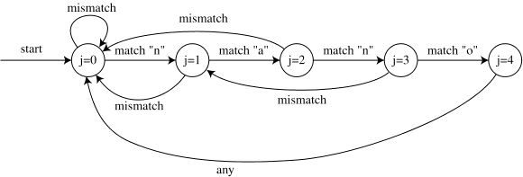
Program Code: | #include <stdio.h>  #include <conio.h>  #include <string.h>  void longest_prefix_suffix(char P[], int f[])  {  int i, j, m;  m = strlen(P);  j = 0;  i = 1;  f[0] = 0;  while(i < m)  {  if(P[i] == P[j])  {  f[i] = j + 1;  i++;  j++;  }  else  {  if(j != 0)  j = f[j-1];  else  {  f[i] = 0;  i++;  }  }  }  printf("\nPrefix-Suffix array is as shown : \n");  for(i = 0; i < m; i++)  printf("%d ", f[i]);  printf("\n");  }  void KMP(char T[], char P[])  {  int i, j, m, n;  int f[100];  longest_prefix_suffix(P, f);  m = strlen(P);  n = strlen(T);  i = 0; j = 0;  while(i < n)  {  if(P[j] == T[i])  {  j++;  i++;  }  if(j == m)  {  printf("\nPattern found at position %d\n", i-j);  j = f[j-1];  }  else if(P[j] != T[i])  {  if(j != 0)  j = f[j-1];  else  i = i + 1;  }  }  }  void main()  {  char T[100], P[100];  clrscr();  printf("\nEnter the Text string : ");  gets(T);  printf("\nEnter the Pattern string : ");  gets(P);  KMP(T, P);  getch();  }
Output Snapshot: | 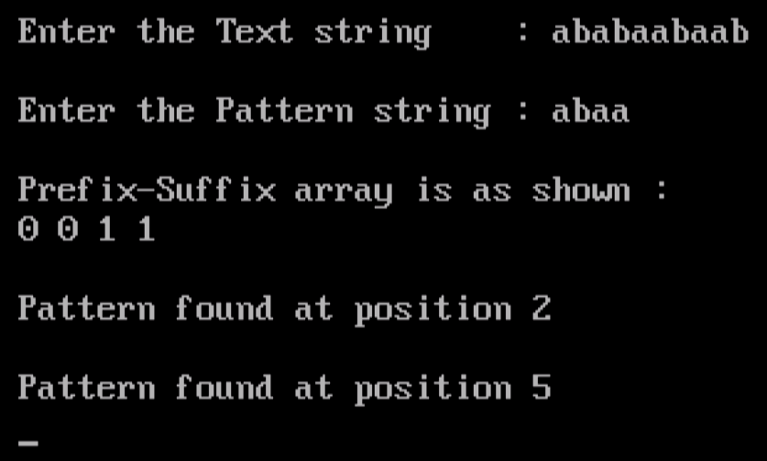  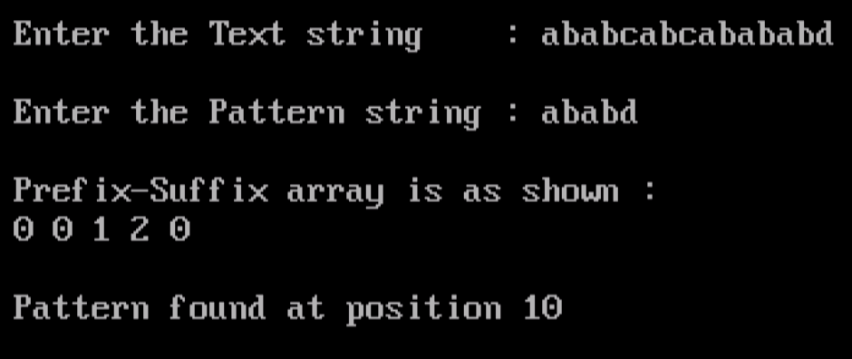
Application | Its imperative applications are Spell Checkers, Spam Filters, Intrusion Detection System, Search Engines, Plagiarism Detection, Bioinformatics, Digital Forensics and Information Retrieval Systems etc.
Outcome: | Successfully implemented Knuth-Morris-Pratt Algorithm for String (Pattern) Matching in C.

